TES-070 Custom Interface Unit Test Results
State of New Hampshire
SoNH_INT_FIN_010 AR Invoice Inbound Interface
Document Properties
Author | Ivy Cafe
Creation Date | 07/18/2025
Last Updated | 07/18/2025
Document Reference | SoNH_ANA-050+DES-020_INT_FIN_AR Invoice Inbound Interface_v1.1.docx
Version | 1.0

Approvals | Position

Document Control

Change Record
1
Date | Author | Version | Change Reference
07/18/2025 | Ivy Cafe | 1.0 | Creation / Initial Draft

Reviewers
Name | Position

Contents
1 Document Control 2
1.1 Change Record 2
1.2 Reviewers 2
2 Custom Interface Unit Test Summary Results 4
2.1 Unit Test Summary 4
2.2 Test Scenarios 4
3 Custom Interface Unit Test Detailed Results 5
3.1 Scenario: Successful Import and Interface of AR Invoice Batch 6
3.2 Scenario: Partial Successfully Interfaced AR Invoice and Partial Interfaced Error AR Invoice 9
3.3 Scenario: Error upon DB Import to AR Invoice Interface (Staging) 13

Custom Interface Unit Test Summary Results
The Custom Interface Unit Test Results consolidate the findings from the specifications written in SONH_ANA-050+DES-020_AR Invoice Inbound Interface. In this section, the summary results are presented for the overall Custom Interface Unit Test.

Unit Test Summary
The following results summarize the counts and percentages for Unit Test:
Count of Total Tests | Count of Completed Tests | % of Completed Tests | Count of Passed Tests | Count of Failed Tests | % of Passed Tests
3 | 3 | 100% | 3 | 0 | 100%

Test Scenarios
Scenario # | Test Scenario | Infor Test Result | SONH Test Result | SONH Tester
3.1 | Successful Import and Interface of AR Invoices | PASS
3.2 | Partial Successfully Interfaced AR Invoices and Partial Interfaced Error AR Invoices | PASS
3.3 | Error upon DB Import to AR Invoice Interface (Staging) | PASS

Custom Interface Unit Test Detailed Results
The Custom Interface Unit Test Detailed Results provide the results for each individual test case.
Tenant: https://mingle-portal.inforcloudsuite.com/v2/NMR2N66J9P445R7P_AX4

Prerequisites for testing:
    - The initiator must have both the Process Server Administrator role (intended solely for testing purposes to allow manual triggering of the interface – otherwise, users must wait five minutes for IPA to trigger automatically) and the Receivables.
Notes: the email notification includes “Link to Interface Result” which would require Receivables Manager role to open the link correctly.
    - Assigned user per Agency must have access to Infor SFTP.
    - User must place the inbound file to the designated SFTP folder: /Infor_FSM/ReceivableInvoiceImport/Inbound
Note: only DEAM resources have access to SFTP who can drop files in the SFTP.
    - Inbound interface file must follow the provided Infor Mapping File format for AR Invoice Interface.
    - Inbound interface file must follow the provided naming convention per file:
      - ARINV_<Agency#><***>_YYYYMMDDHHMM.csv
      - ARDIS_<Agency#><***>_YYYYMMDDHHMM.csv
Notes:
      - *** = Acronym of External Sub System; defined by the agencies:
      - multiple Rungroup under one file name are not allowed for security administration purposes.
      - YYYYMMDDHHMM = Year, month, date, hour and minute of upload
      - In case the inbound interface file didn’t follow the naming convention, the file will not be processed and will stay in the sftp.

    - Email configuration setup for recipients.
Navigation Path: Process Server Administrator Role > Configuration > System Configuration > FSM > Search Property Name:
      - FSM_FIN_ReceivableInvoiceImport_INT_010_EmailTo
      - FSM_FIN_ReceivableInvoiceImport_INT_010_ErrorEmailTo
      - FSM_FIN_ReceivableInvoiceImport_INT_010_EmailCC
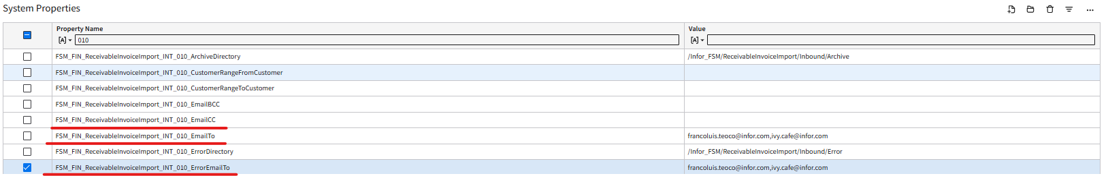
    - Multiple emails can be assigned, with comma “,” as a separator.
    - This configuration is expected to receive notifications for the following:
      - FSM_FIN_ReceivableInvoiceImport_INT_010_EmailTo
- for Successful Import and Successful Interface, and Interface Error
- FSM_FIN_ReceivableInvoiceImport_INT_010_ErrorEmailTo
- for Import Error and Interface Error
- FSM_FIN_ReceivableInvoiceImport_INT_010_EmailCC
- for Successful Import and Successful Interface

Note: comma “,” should be used as a separator in adding multiple emails
(i.e angeli.pineda@infor.com,joshua.adato@infor.com)
- "This interface will run on a scheduled basis through scheduling. The IT team will be responsible for the setup and ongoing maintenance of these schedules. For detailed setup instructions, please refer to the following document: <Link to Technical Master File>. "

Scenario: Successful Import and Interface of AR Invoice Batch

Description
Agency creates the AR Invoice inbound files based in FSM format with populated information related to AR Invoices and drop these files to Infor SFTP.

Test Steps
No. | Steps | Result
1 | - Log into FTP Program using the Infor SFTP credentials  - Navigate to this Folder directory:  /Infor_FSM/ReceivableInvoiceImport/Inbound  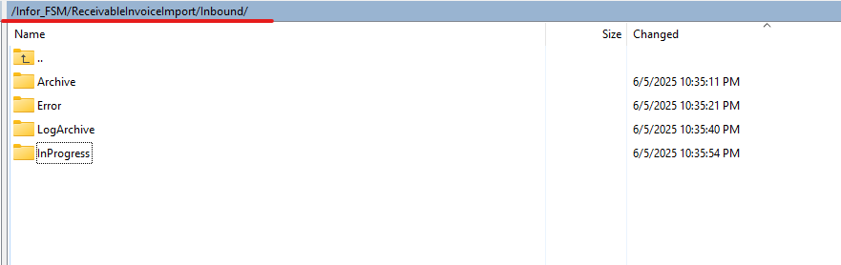  - Drop the AR Invoice inbound files in the directory.  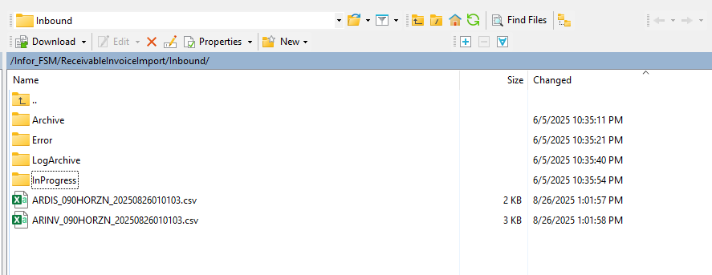  - Wait for file channel to trigger scanning (currently scheduled every 5 mins)  - For manual trigger for the file scanning, refer to Step 2 | PASS
2 | - Log into Infor FSM as Process Server Administrator > Administration > Channels Administrator > File Channels tab > Search for SONH_ReceivableInvoiceImport in the Channel Name.  - Right click and click Scan Now.  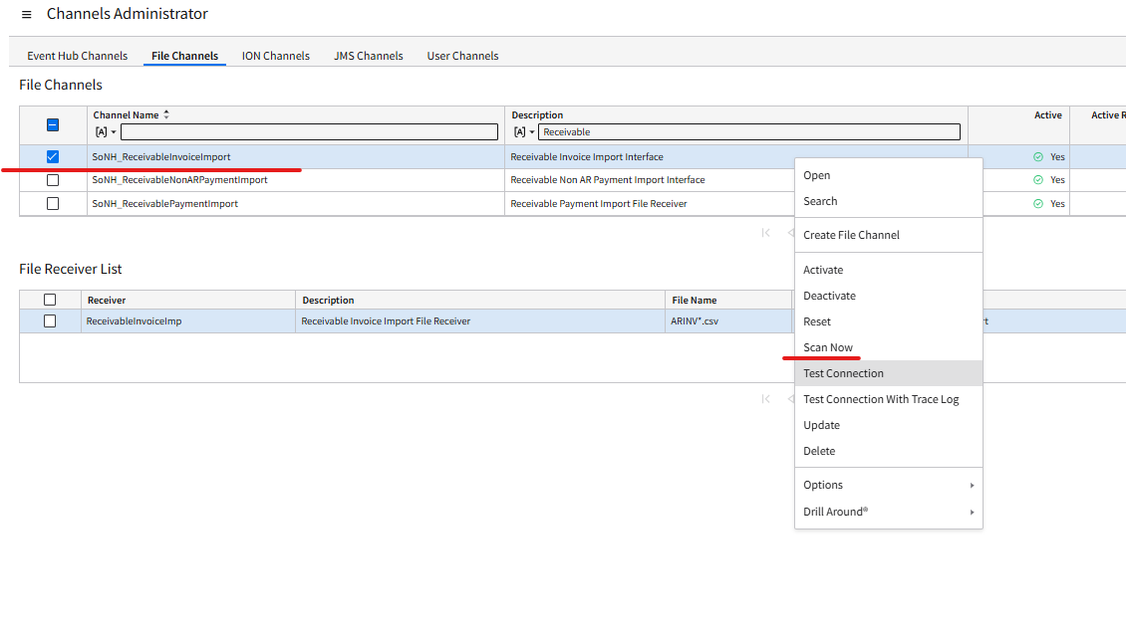  - Last Message Received Time of the ReceivablleInvoiceImport under the File Receiver List would be updated to the current date and run time.  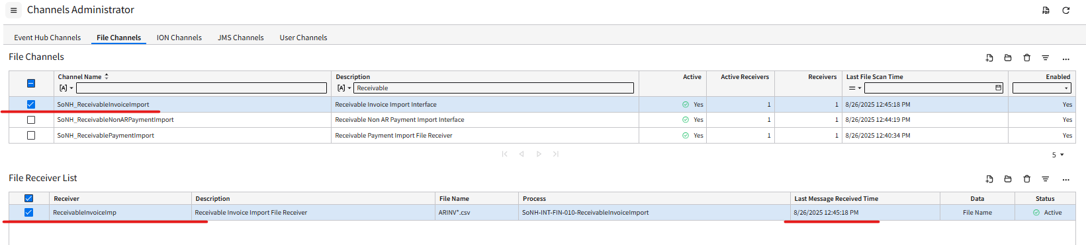  - Files would be consumed when the FTP Program folder is refreshed.  - File are imported to ReceivableInvoiceImport staging business class  - Automatic interfacing of imported data to FSM via IPA | PASS
3 | - Email notification is sent to user for Successful Load of data. Click on the email link to view the results. The email notification also includes the number of records successfully interfaced which is based on the number of AR Invoices.  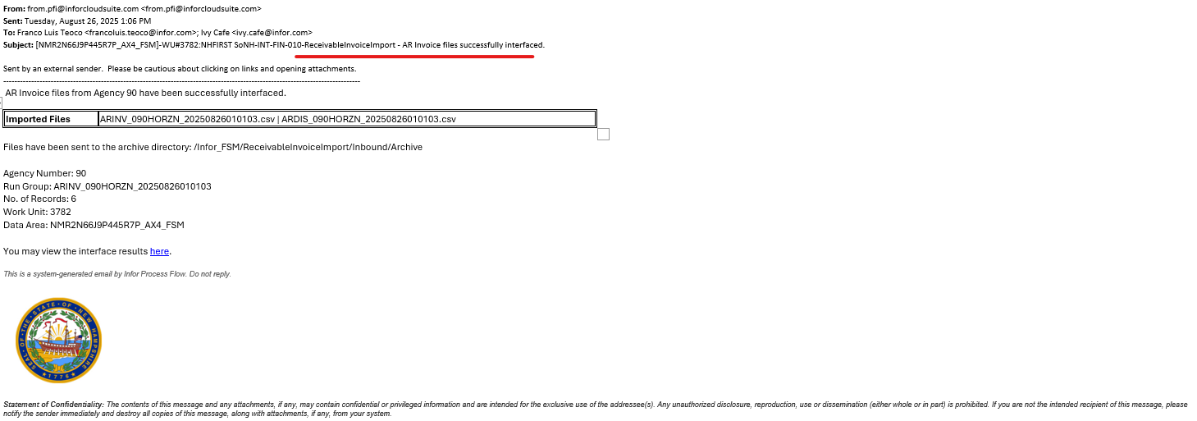  - Double-click the Link to Interface Result in the email notification.  Note: as mentioned in the Pre-Requisites section, accessing the ‘Link to the Interface Result” in the email would require users to have “Receivables Manager” role  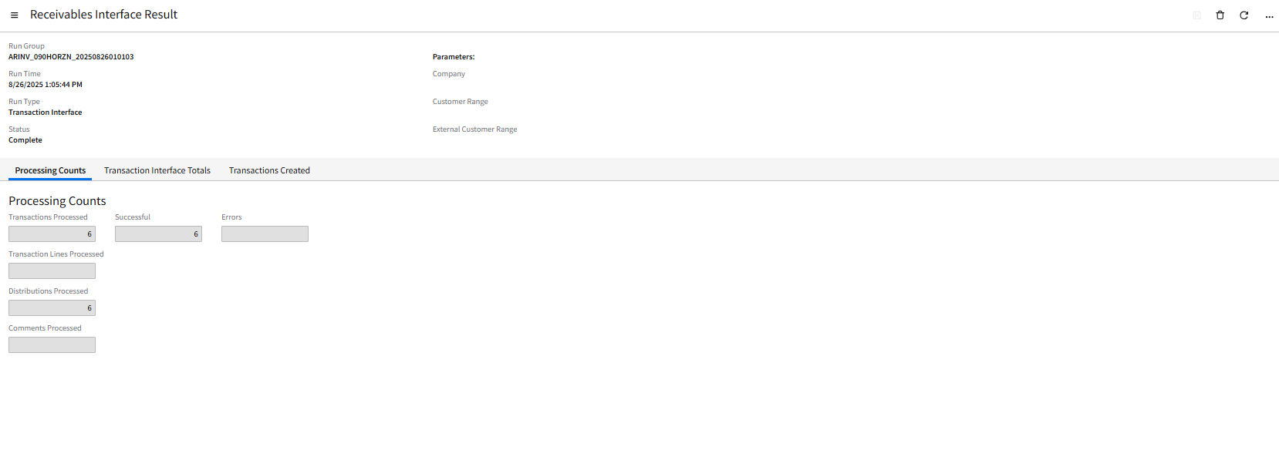  - Under Transactions Created tab, a list of the AR invoices created are displayed.  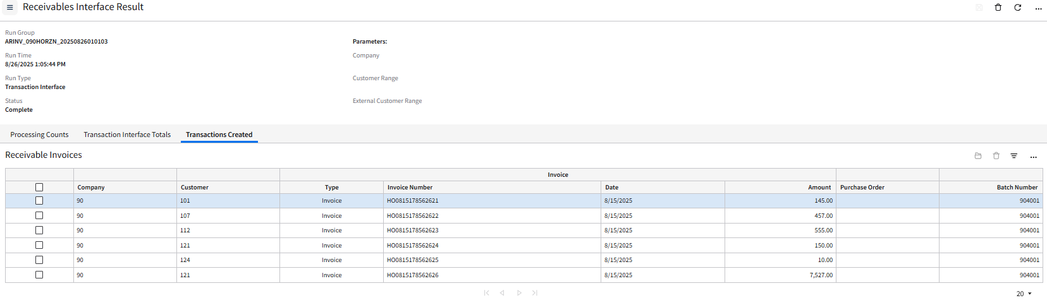  - Note the link from the email will direct to the Interface Result for the RunGroup. To Manually navigate on the Interface Results:  Receivable Manager>Interface>Interface Maintenance>Results  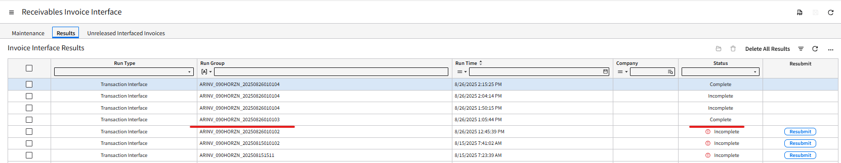 | PASS
- The work unit generated can also be checked to ensure that the IPA process ran smoothly without errors. This is where the Process Server Administrator should go should there be any errors encountered in the processing.

Navigation Path: Process Server Administrator role > Administration > Work Units > Work Units > check the Work Unit status - “Completed”.

Results
- Files placed in SFTP folder with the correct file naming conventions are consumed by IPA.
- A work unit is created for the processing of the files.
- Files are imported to ReceivableInvoiceImport and ReceivableInvoiceImport staging business classes.
- IPA automatically interfaces the imported data in FSM.
- AR Invoices are successfully created in FSM in Released Status.
    - Email notification is sent to users for Successful Load of data.

Scenario: Partial Successfully Interfaced AR Invoice and Partial Interfaced Error AR Invoice

Description
- For instances when run group resulted in some AR Invoice being successfully interfaced and some invoice encountered interface errors.
- Interface files which include records that will encounter interface errors due to, but not limited to, the following reasons:
  - Records interfacing dated in closed periods.
  - The Invoice amount is not net to Zero
  - Customer records in the interface file do not exist in FSM.
  - Other setups or configurations that do not exist or do not match with the other data values (i.e Cash Code, Process Level, Customer not existing for Agency, etc.)
Note: FSM-converted Customer Numbers differ from the legacy customer number. Agency can utilize Customer Reference 2 field in the Customer business class to view the legacy customer numbers which can be extracted through Infor Spreadsheet Designer (ISD) for reference. A complete set of customers will be made available in the SIT tenant.
Navigation Path: Receivables Manager > Customers > Customer List
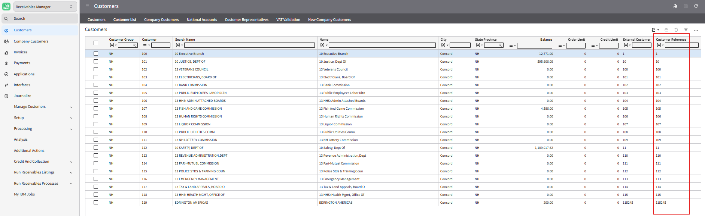

Test Steps
No. | Steps
1 | - Log into FTP Program using the Infor SFTP credentials  - Navigate to this Folder directory:  /Infor_FSM/ReceivableInvoiceImport/Inbound  - Drop the AR Inbound files in the directory.  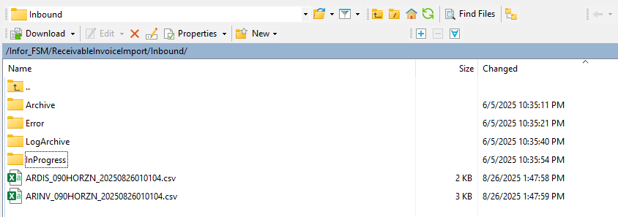  - Wait for file channel to trigger scanning (currently scheduled every 5 mins)  - For manual scanning refer to Step 2 | PASS
2 | - Log into Infor FSM as Process Server Administrator > Administration > Channels Administrator > File Channels tab > Search for SONH_ReceivableInvoiceImport in the Channel Name.  - Right click and click Scan Now.  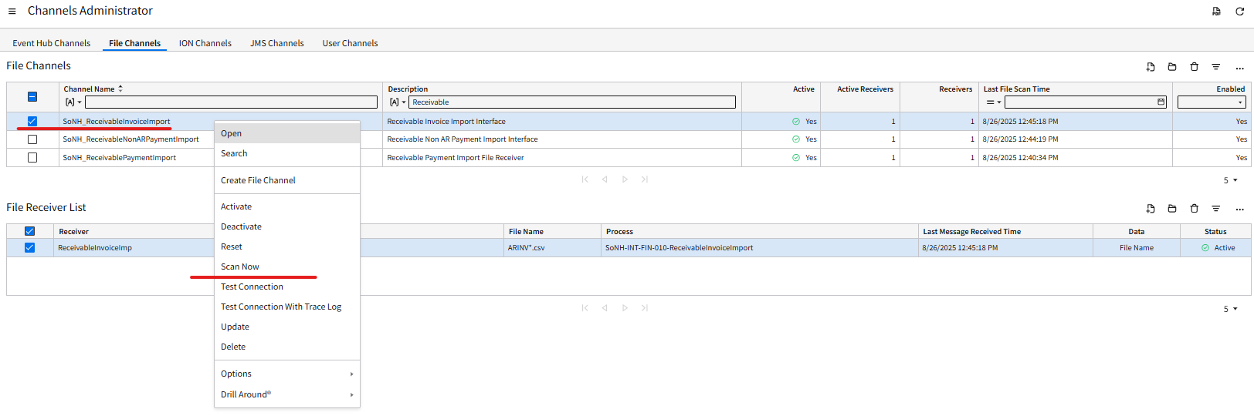  - Last Message Received Time of the ReceivableInvoiceImport under the File Receiver List would be updated to the current date and run time.  - List would be updated to the current date and run time.  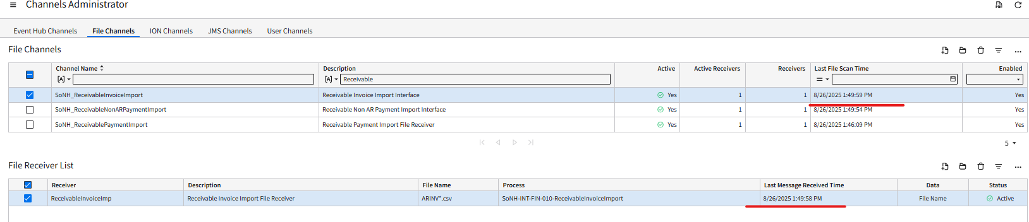
3 | - Files would be consumed when the FTP Program folder is refreshed.  - Records are imported to ReceivableInvoiceImport and ReceivableInvoiceDistributionImport staging business classes, and interface action will automatically be triggered by IPA.  - Email notification would be sent containing the number of invoices successfully-interfaced and number of invoices that encountered interface errors within the error run group.  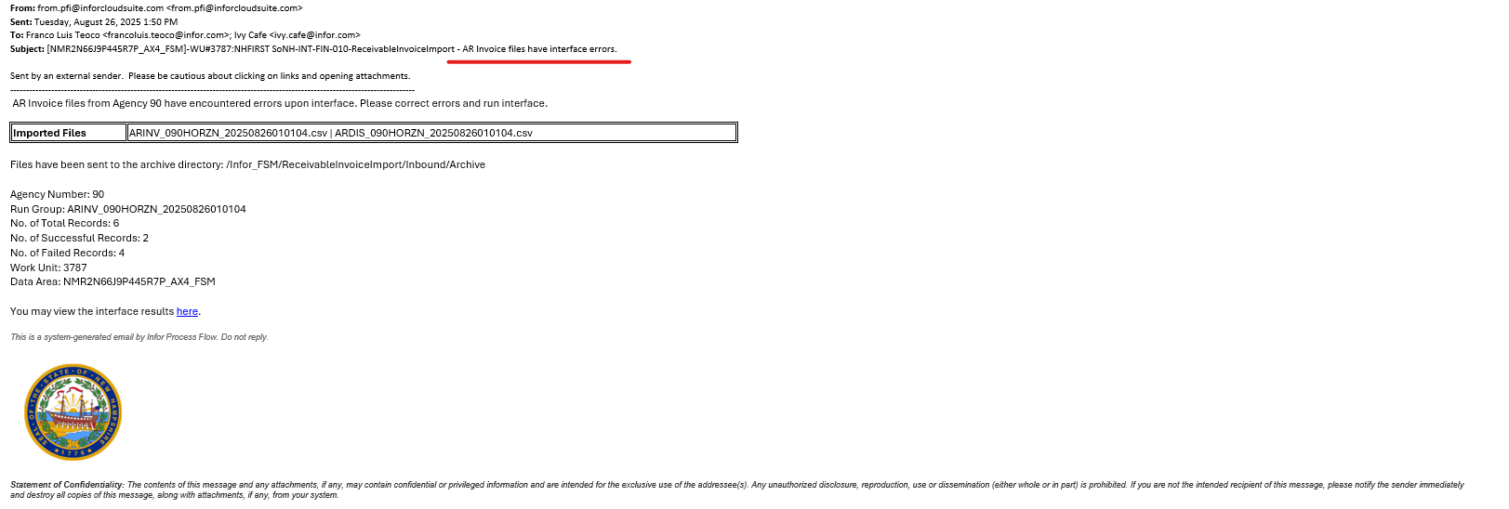 | PASS
4 | - Double-click to open the link in the error email notification received.  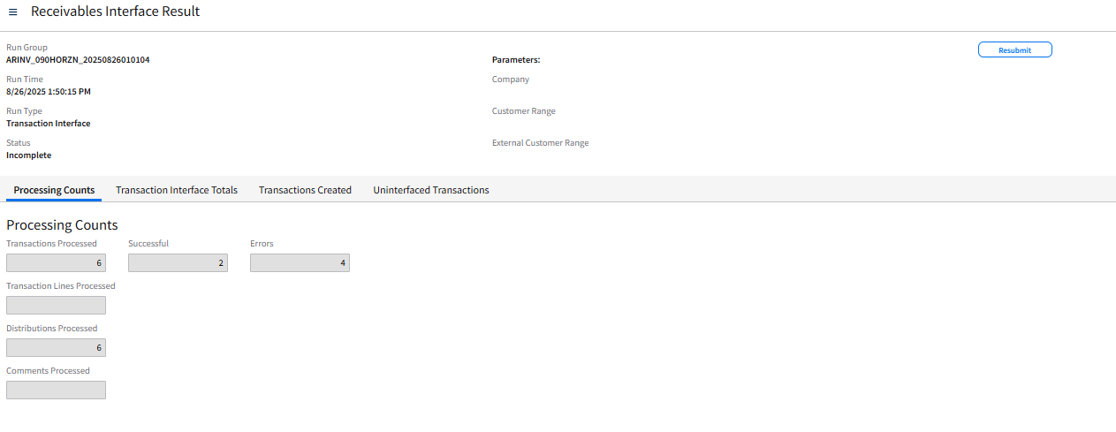  - Successfully interfaced records can be seen in the “Transactions Created” tab.  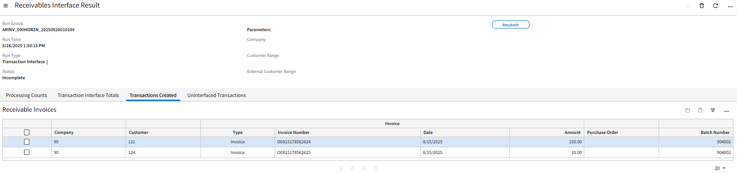  - Under Uninterfaced Transactions tab, the list of the AR Invoices were unsuccessfully interfaced are listed with “Error Message” for each invoice.  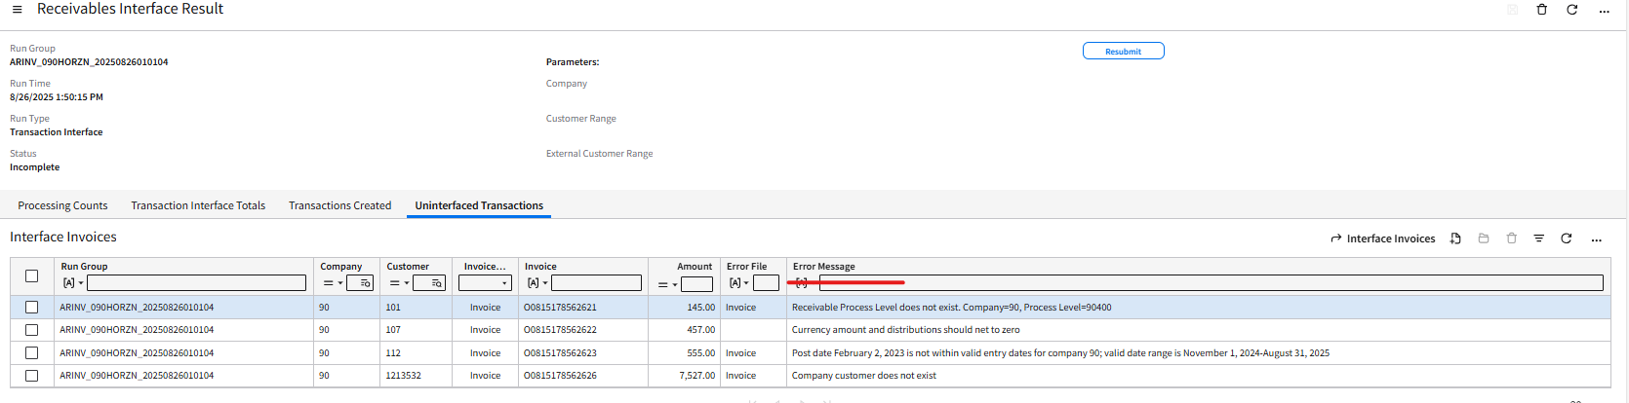  - Double-click the record with error to open and correct the specific error. In this scenario, the one with the Process Level error will be corrected.  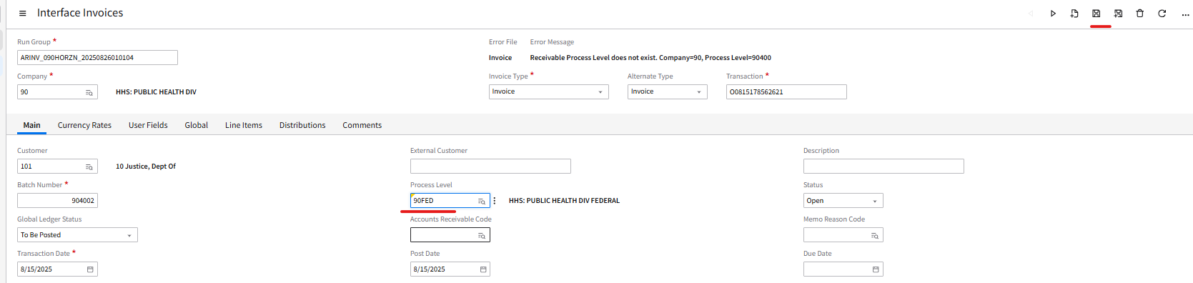  - Update the process level and hit save.  - Once updates are made, select the records and click “Reset Error Messages”.  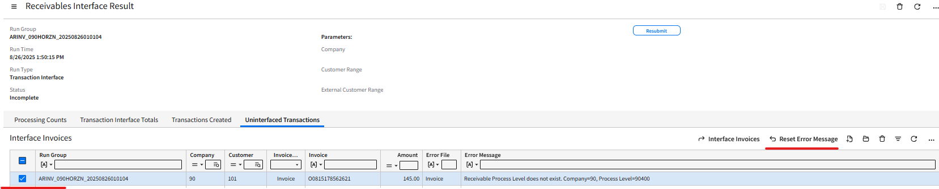  - Click Interface Interface Invoices and fill out the required fields with red asterisk (*), and hit submit and hit refresh.  Note: “Resubmit” button in the right section can also be used to directly trigger the interface action.  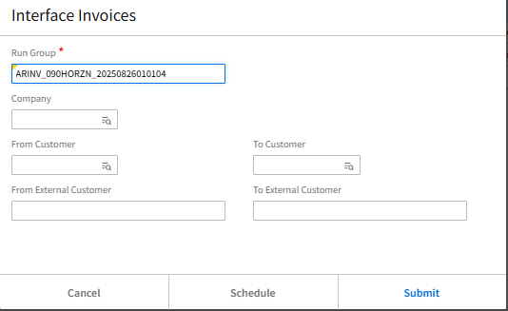  - Go back to the Interface Results  Navigation: Receivable Manager>Interfaces>Invoice Maintenance>Results>Double Click on the RunGroup  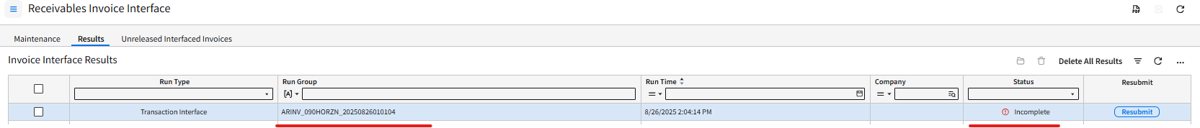  - Review Invoices in Transactions Created and Uninterfaced Transactions tab  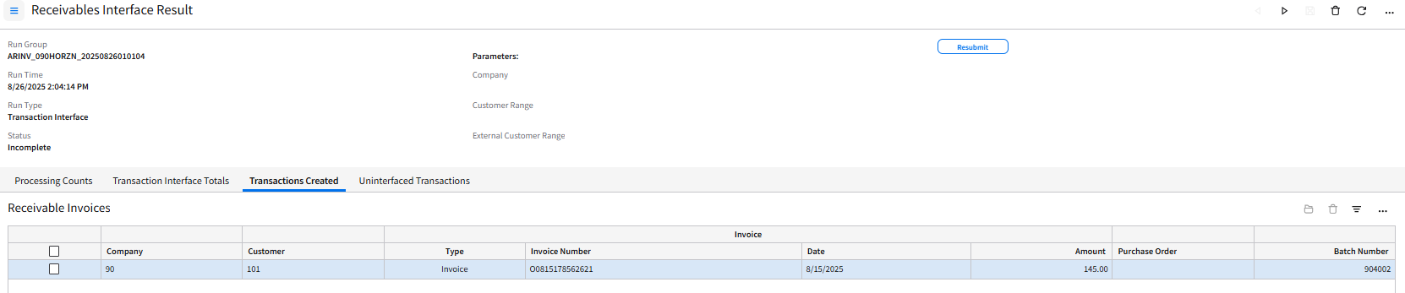  - Once all the Invoices are corrected and resubmitted, Interface Result will be in Complete status.  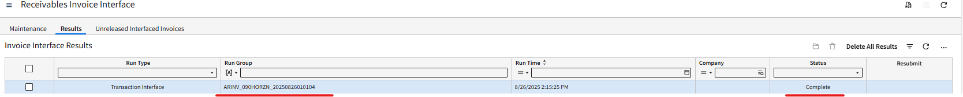 | PASS

Results
- Email notification was sent containing the number of invoices successfully interfaced and number of invoices that encountered interface errors.
- User was able to reprocess the records with error after the necessary updates are made.

Scenario: Error upon DB Import to AR Invoice Interface (Staging)

Description

When a user submits an inbound interface file to FSM with DB import issues - IPA will process the AR Invoice interface files, validate the data, and return any detected errors.
- The interface files may encounter DB Import issues due to, but not limited to, the following reasons:
  - Incorrect data format (i.e date formatting – YYYYMMDD, etc)
  - Misspelled headers or improper header formatting; column headers do not match FSM fields.
  - Duplicate invoices.
Note: the interface files with incorrect file naming convention will not be processed by FTP.

Test Steps

No. | Steps | Result
1 | - Log into FTP Program using the Infor SFTP credentials  - Navigate to this Folder directory:  /Infor_FSM/ReceivableInvoiceImport/Inbound  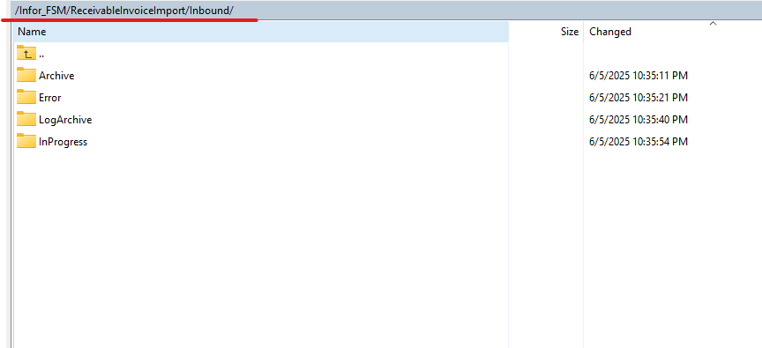  - Drop the AR Inbound files in the directory.  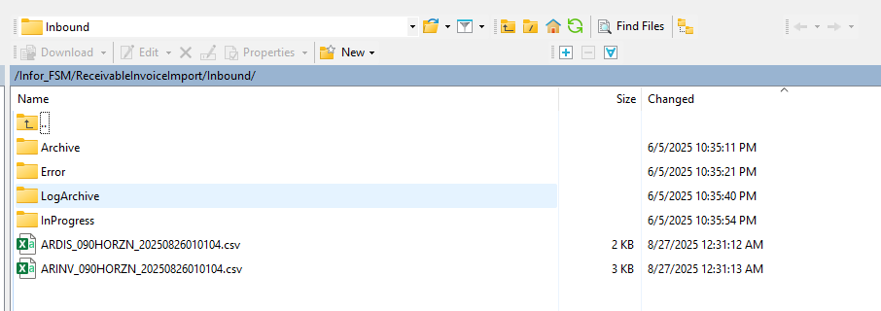  - Wait for file channel to trigger scanning (currently scheduled every 5 mins)  - For manual scanning refer to Step 2 | PASS
2 | - Log into Infor FSM as Process Server Administrator > Administration > Channels Administrator > File Channels tab > Search for SONH_ReceivableInvoiceImport in the Channel Name.  - Right click and click Scan Now.  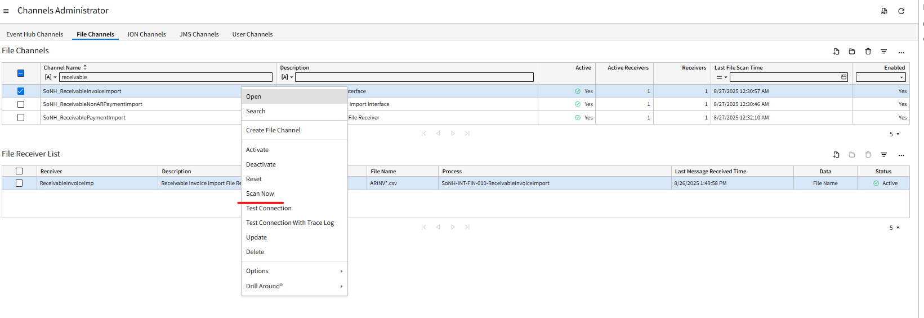  - Last Message Received Time of the ReceivableInvoiceImport under the File Receiver List would be updated to the current date and run time.  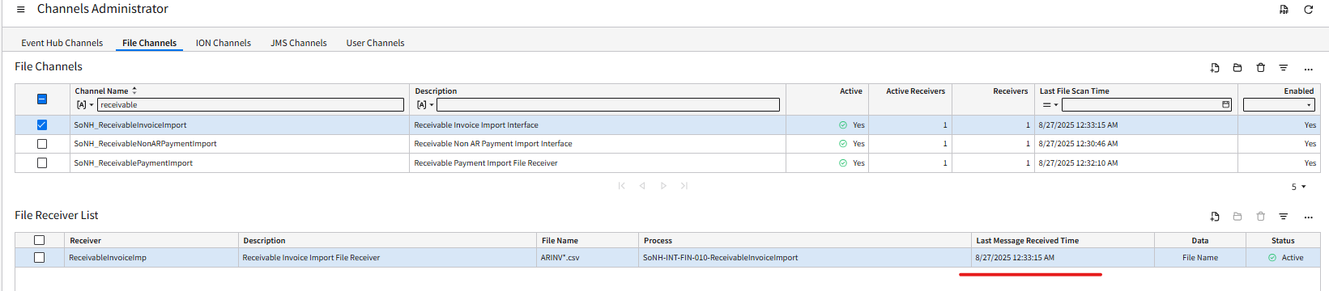 | PASS
3 | - Files would be consumed when the FTP Program folder is refreshed,  - Records with error are not imported to ReceivableInvoiceImport staging business class due to DBImport errors. Thus, records will not move to the next process and be interfaced.  NOTE: if the record, either the Invoice or Invoice Distribution record, does not have any error then it would get loaded into the ReceivablesInvoiceImport.  - An email notification will be sent with the DB import error attached.  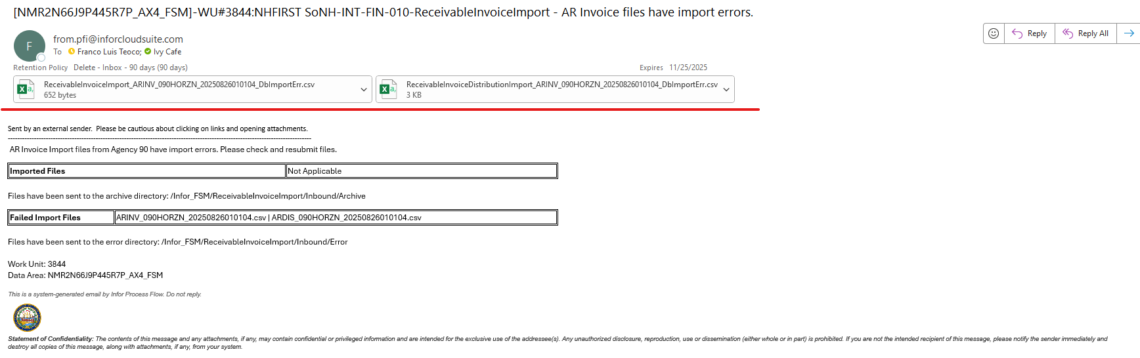  - Open attached ReceivableInvoiceImport error files report to view errors. Below are sample errors in the report file:  Incorrect data formatting  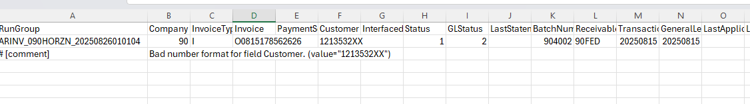  Incorrect Header field error  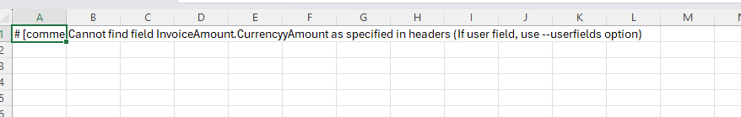  Duplicate Invoice number within the same Rungroup, Company – still in Staging Table  - User to correct the interface file based on the error and repeat the process (Step 1) | PASS

Results
- Files are not imported to ReceivableInvoiceImport staging business class due to DBImport errors.
- An email notification will be sent with the DB import error attached.

